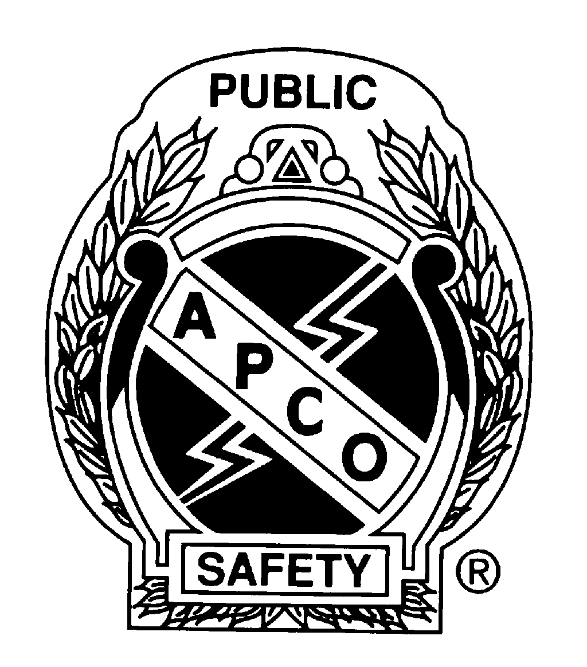 Public Safety Telecommunicator 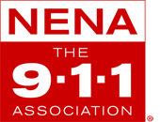Scholarship Application Form
17th Annual Wyoming APCO/NENA Conference
November 6, 7, and 8, 2017

The Wyoming APCO/NENA Chapter presents the Public Safety Telecommunicator Scholarship. A scholarship designed to assist Wyoming public safety telecommunicators in pursuing their passion to make the world a safer place. The scholarship will pay for the recipients’ registration fee to the 17th Annual Wyoming APCO/NENA Conference in Casper on November 6, 7, and 8, 2017 valued at $150 with 20 POST training hours and 1 night hotel stay (your center pays for the rest of the lodging fee).

Last Name: First Name: Middle Initial:
Title: Agency:
Address: City: State: Zip:
Phone: Email:

Work Experience:

Community Involvement:

Career Goals:

In your own words, submit a 500+ word essay describing your view on the following topic: You Don’t Need A Title To Be A Leader. The essay must be original and written by the applicant. The essay should be based on accurate research, industry knowledge and realistic concepts, ideas, and technologies.

Send Application and Essay to: Wyoming APCO/NENA Chapter % Terri Sherman
PO Box 1885
Jackson, Wyoming 83001
307-732-8303
tsherman@tetonsheriff.org

Scholarship Application Submittal Deadline is September 15, 2017
Scholarship award winners will be notified on September 22, 2017

► Hotel Information ◄
A block of rooms at the Ramkota (307)266-6000 has been reserved at the special rate of $83.00/night, which includes breakfast. When making your reservations, be sure to reference WYAPCO/NENA to receive this special rate.

If you have questions please contact: Terri Sherman at tsherman@tetonsheriff.org or 307-732-8303
You may also download this form at the WYAPCO/NENA Chapter web site: http://wyomingapco.com/

